**Health Mug-Clone (Project)**

**Unit-2 Construct Week Project**

* **CONTENTS OF THIS FILE**

1. Introduction
2. Languages
3. Requirement & Reference
4. Configuration
5. Contributors
6. About Us

* **Introduction: -**

This project Aims to make clone website of Health Mug website, we got a task to make same website as Health Mug by using Local Storage.

* **Language In Projects: -**

HTML, CSS, Java Script

* **Requirement && Reference: -**

To make this clone we Need data of product so, firstly we collect the data from website. Also, for the sliding part and some CSS part we were taking Help from google.

* **Configuration: -**

We made homepage first after that there are 6 subpages according to products like allopathic, homeopathy, ayurveda, etc. and we made many more subpages in those pages like log in, sign in, cart etc.

**-->Homepage: -**

**navbar: -**

for the navigation bar and search we had given several clicks function in java script for this header cv also we have uses z index, after that for this sliding images we use slideshow by incrementing slide length and using opacity. same process we are use also in sliding products. remaining is just a html and CSS.

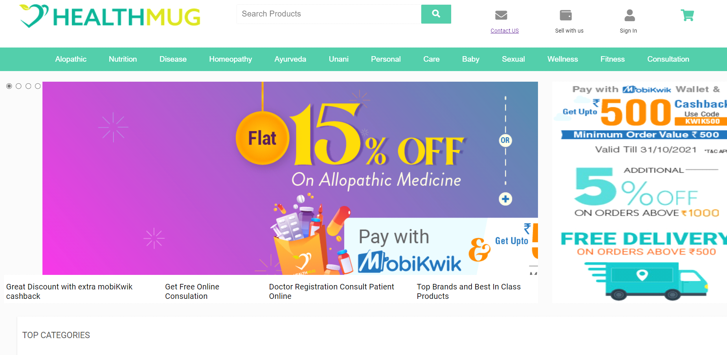

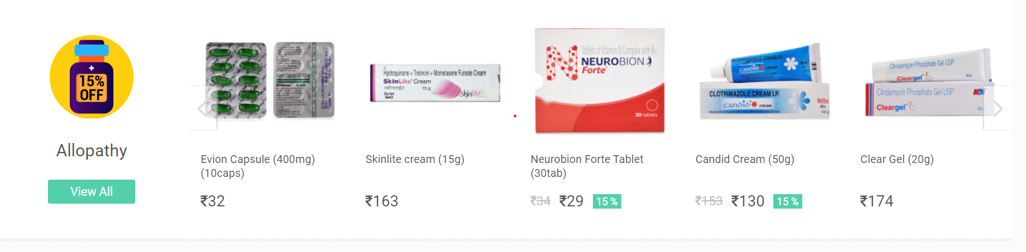

For every button we have given specific path of particular subpage, also for the products we given product description page.

And in every page we add footer like as Health Mug website, For this we are given click function for every button.

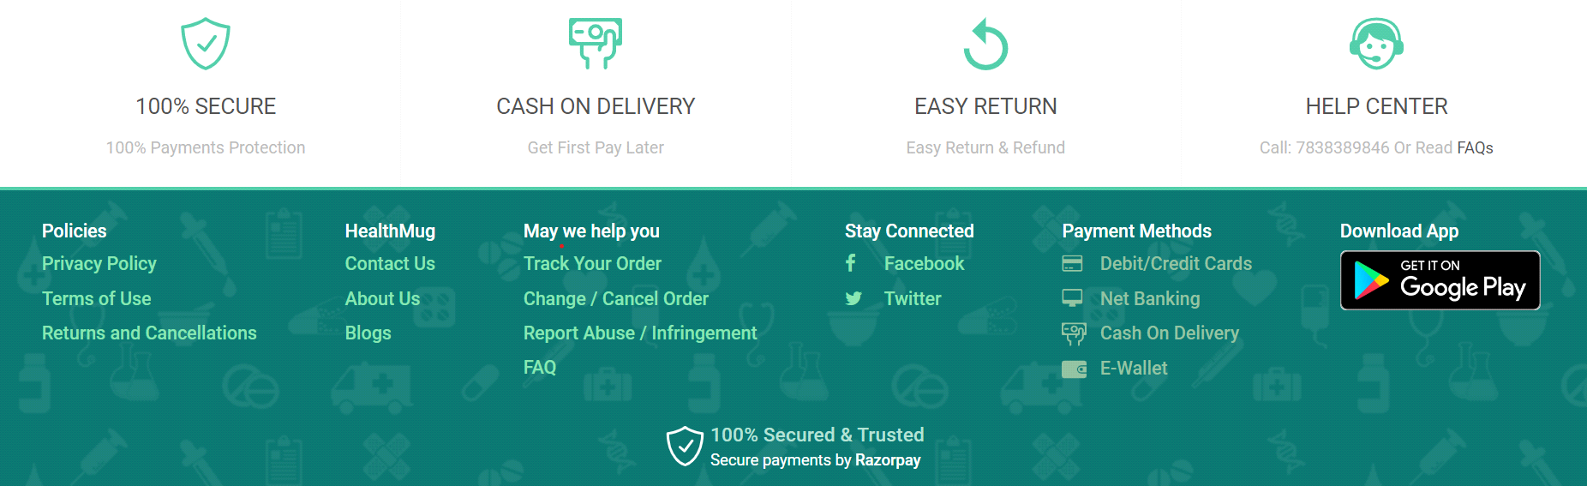

We had made Signup page and Log in page, store all the data in local storage for the button continue and submit we given a function for email, phone no and password.

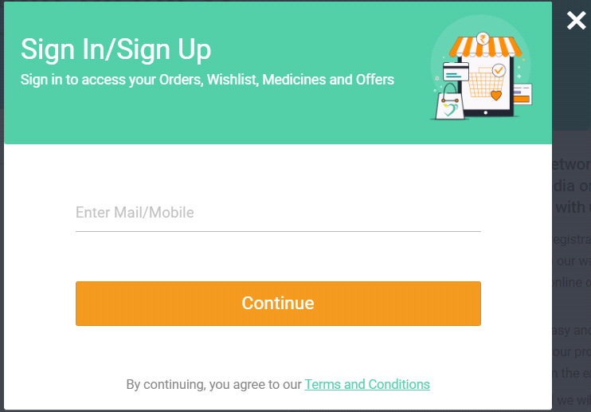

**-->Other Subpages: -**

other pages like allopathy, homeopathy, ayurveda, unani, nutrition and beauty care in these pages we are mapping the whole product and stores in local storage. For the JavaScript we are sorting the products by price, name, and brands. Also, we given filter function for Brands.

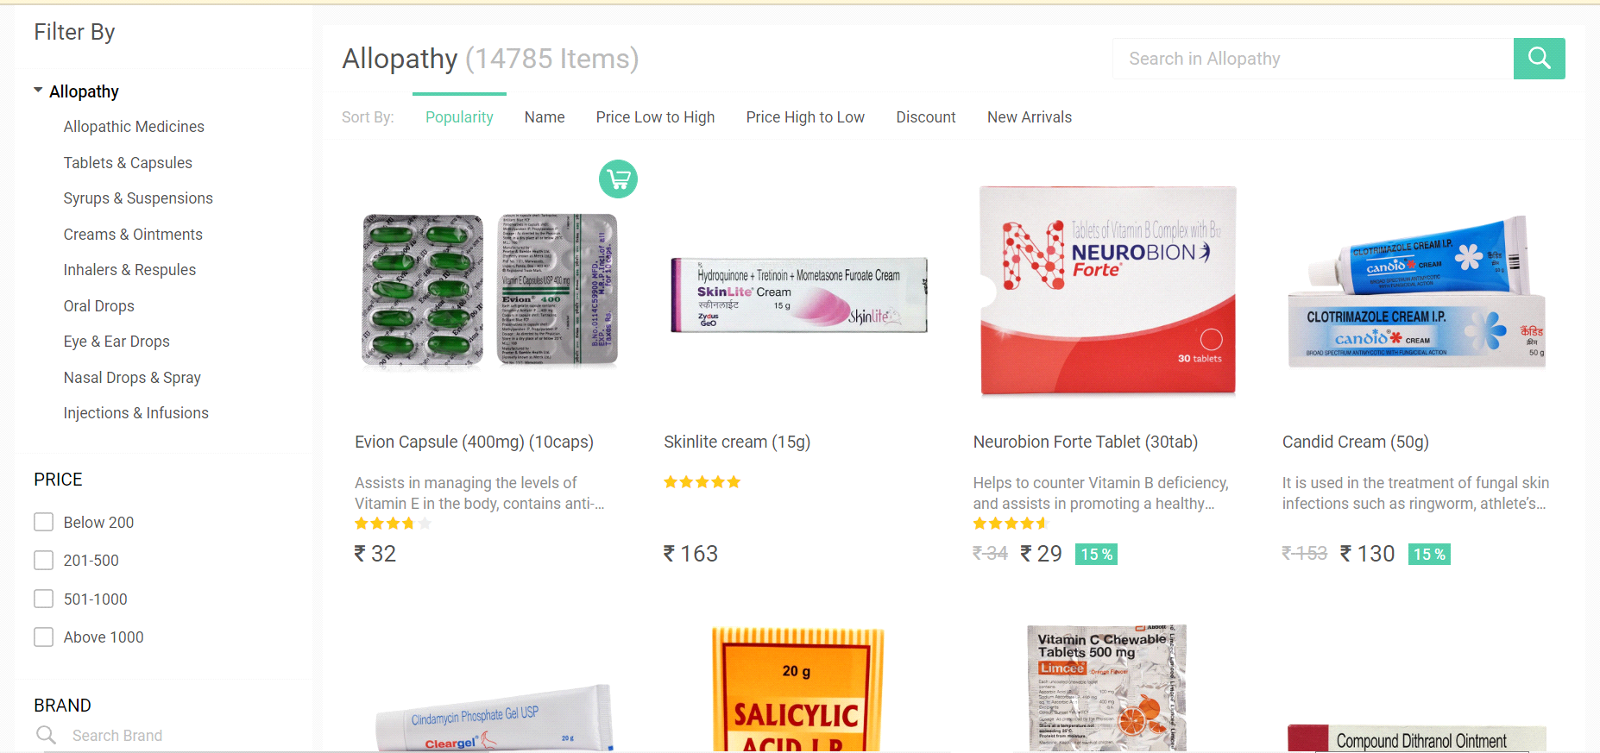

When we click on specific product then we created another page for option Buy now and Add to cart, We also created Cart page for our selected products save in cart.

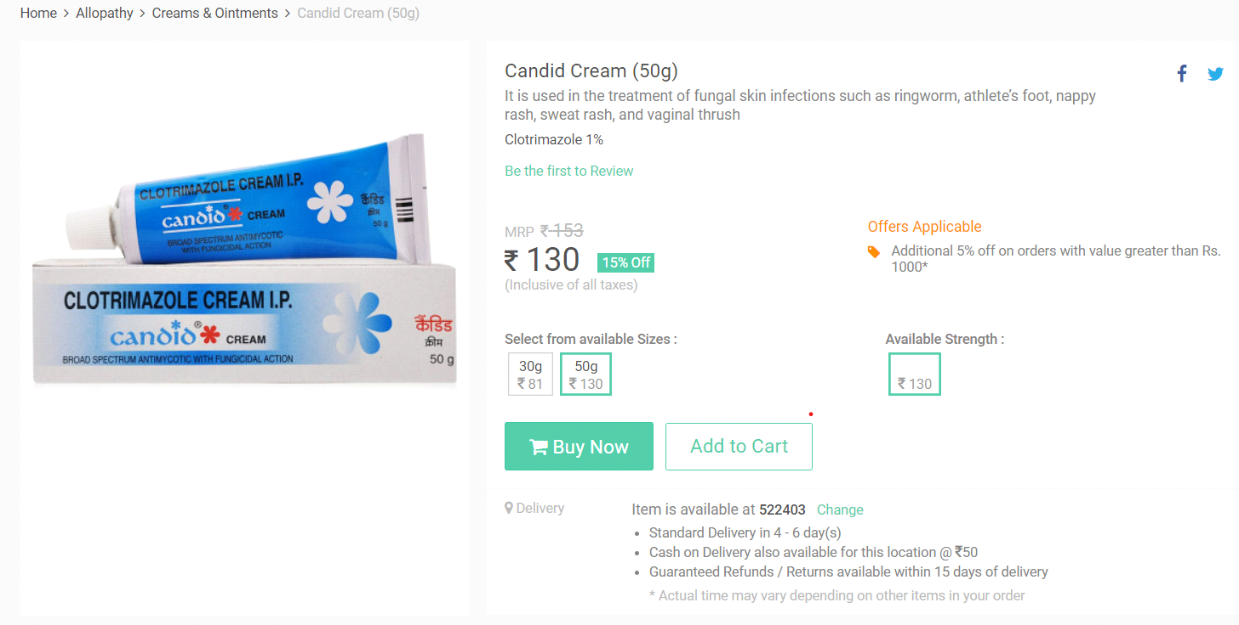

We are also given checkout page, for asking clients to their address and their pin code for sending them the products, also we given payment option in this checkout page.

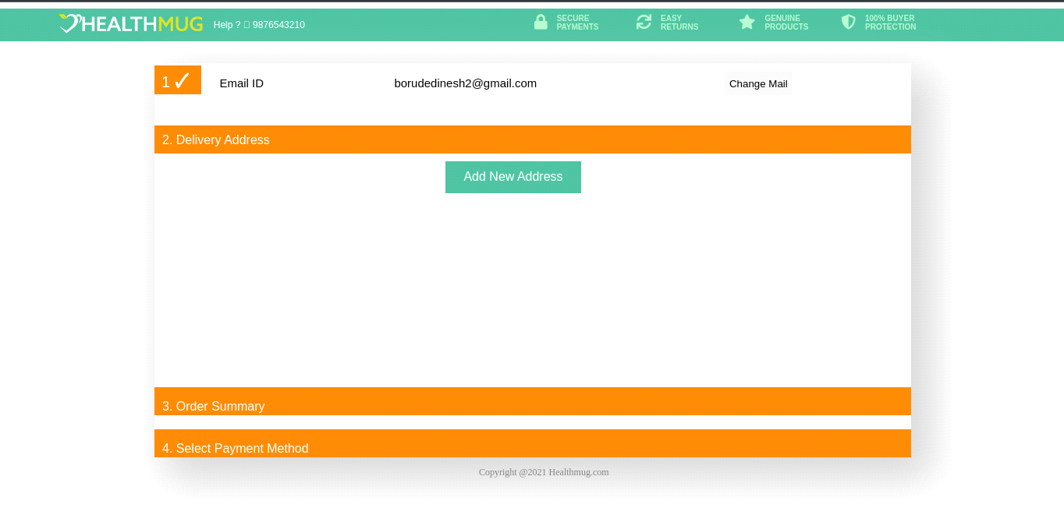

We also made contact us page and sales with us page, store all this data in local storage by giving them function...

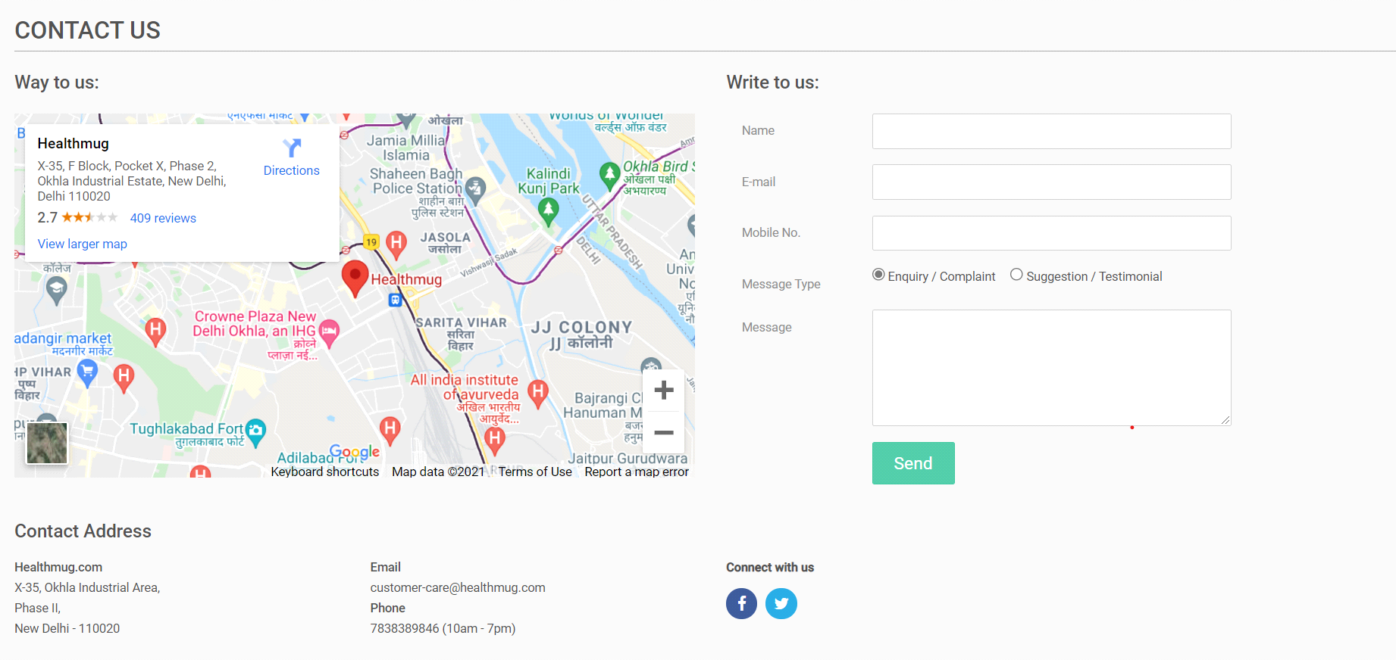

this page is sale with us.

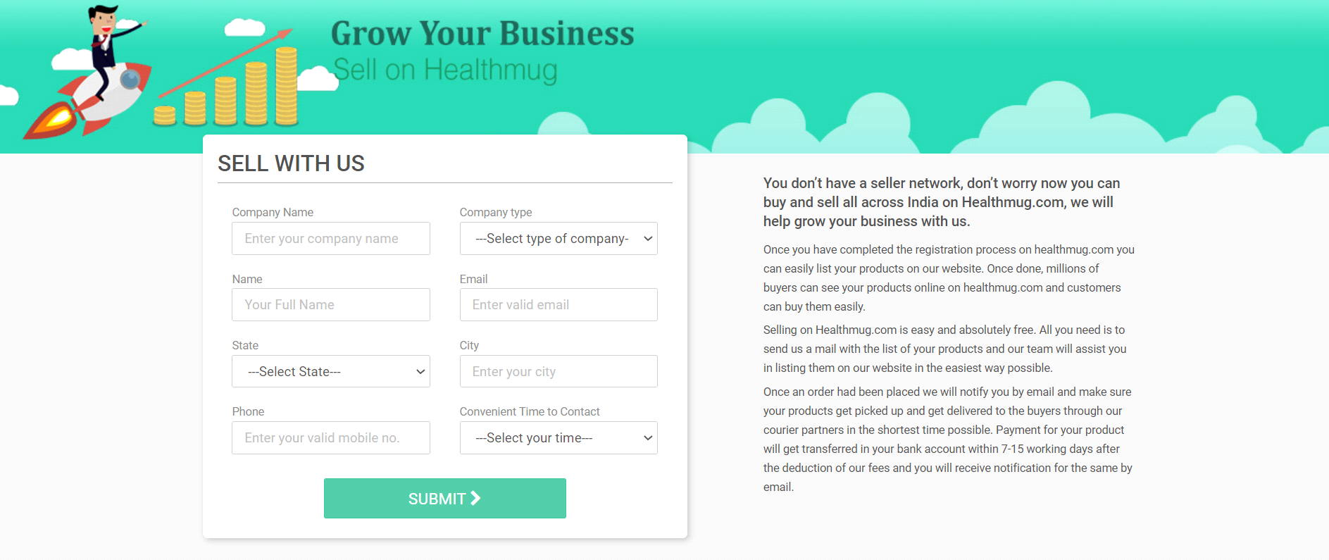

we are also made dummy payment page giving some dummy OTP’s and card number length and CVV length.

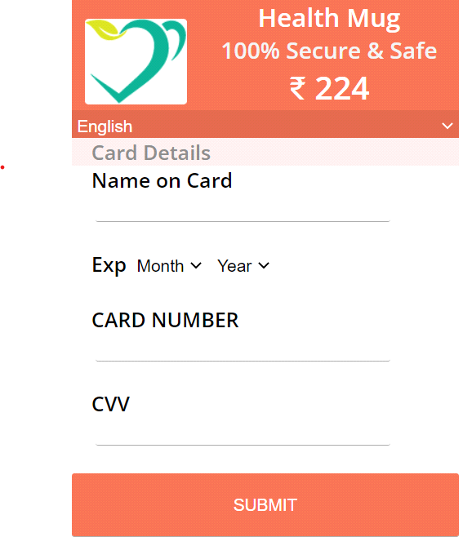

* **Contributors: -**

1. Akshay (Team Leader)
2. Sandeep
3. Aditya
4. Sivanandam
5. Dinesh
6. Saiprasad

* **About Us: -**

We are a student of batch FW13 of unit 2 of Masai school. This is our first project. We had a task to make Health Mug Website clone and We done this job in just 8 days. We had 6 Members team. We were trying our best to complete this Project.